PREFIX SUM
vector<int> prefix(n);
prefix[0] = arr[0];

for (int i = 1; i < n; i++)
prefix[i] = prefix[i - 1] + arr[i];

int rangeSum(int L, int R, vector<int>& prefix) {
if (L == 0) return prefix[R];
return prefix[R] - prefix[L - 1];
}

2D PREFIX SUM

vector<vector<int>> buildPrefix(vector<vector<int>>& a) {
int n = a.size(), m = a[0].size();
vector<vector<int>> pre(n, vector<int>(m, 0));

for (int i = 0; i < n; i++) {
for (int j = 0; j < m; j++) {
pre[i][j] = a[i][j];
if (i > 0) pre[i][j] += pre[i - 1][j];
if (j > 0) pre[i][j] += pre[i][j - 1];
if (i>0 && j>0) pre[i][j] -= pre[i-1][j-1];
}
}
return pre;
}

int query(int l1, int r1, int l2, int r2, vector<vector<int>>& pre){
int res = pre[l2][r2];
if (l1 > 0) res -= pre[l1 - 1][r2];
if (r1 > 0) res -= pre[l2][r1 - 1];
if (l1 > 0 && r1 > 0) res += pre[l1 - 1][r1 - 1];
return res;
}

SUFFIX SUM

vector<long long> sfx(n + 1, 0);

for(int i = n - 1; i >= 0; i--){
sfx[i] = sfx[i + 1] + a[i];
} // 0 based

vector<long long> sfx(n + 2, 0);

for(int i = n; i >= 1; i--) {
sfx[i] = a[i - 1] + sfx[i + 1];
} // 1 based

DIFFERENCE ARRAYS

vector<int> diff(n + 1, 0); //0 based

diff[L] += X;
diff[R + 1] -= X;

vector<int> arr(n, 0);
arr[0] = diff[0];

for (int i = 1; i < n; i++)
arr[i] = arr[i - 1] + diff[i];

OR

for (int i = 1; i < n; i++)
diff[i] += diff[i - 1];

SUBARRAY SUM

Used to count number of subarrays with sum = K

map<int,int> mp;
mp[0] = 1;
int sum = 0, cnt = 0;

for (int x : arr) {
sum += x;
cnt += mp[sum - k];
mp[sum]++;
}

Return cnt;

sum: keeps track of the prefix sum up to index i.
mp: stores how many times each prefix sum has appeared so far.
mp[sum] = number of subarrays that have prefix sum equal to sum.
ans: total count of subarrays whose sum is equal to x.

TWO POINTER

//Works only for sorted arrays

bool twoSumSorted(const vector<int>& arr, int target) {
int n = arr.size();
if (n < 2) return false;
int l = 0, r = n - 1;
while (l < r) {
int sum = arr[l] + arr[r];
if (sum == target) return true;
else if (sum < target)l++;
else r--;
}
return false;
}

SLIDING WINDOWS
//k - size of subarray
int maxSumSubarray(int arr[], int n, int k) {
int currSum = 0;
for (int i = 0; i < k; i++) currSum += arr[i];

int maxSum = currSum;

for (int i = k; i < n; i++) {
currSum += arr[i];
currSum -= arr[i - k];
maxSum = max(maxSum, currSum);
}

return maxSum;
}

SIEVE OF ERATOSTHENES
Vector <int> sieve(int n) {
vector<bool> isPrime(n + 1, true);
isPrime[0] = isPrime[1] = false;

for (int i = 2; i * i <= n; i++) {
if (isPrime[i]) {
for (int j = i * i; j <= n; j += i)
isPrime[j] = false;
}
}

vector<int> primes;
for (int i = 2; i <= n; i++) {
if (isPrime[i]) primes.push_back(i);
}
return primes;
}

SMALLEST PRIME FACTOR

Vector <int> sievespf(int n) {
vector<int> spf(n + 1);

for (int i = 0; i <= n; i++)
spf[i] = i;

for(int i = 2; i * i <= n; i++) {
if(spf[i] == i) { // i is prime
for(int j = i * i; j <= n; j += i) {
if(spf[j] == j)
spf[j] = i;
}
}
}
return spf;
}

DISTINCT PRIME FACTOR

vector<int> prime_factor;

for (int i = 2; i * i <= n; i++) {
if (n % i == 0) {
prime_factor.push_back(i);

while (n % i == 0) {
n /= i;
}

}
}

if (n > 1) {
prime_factor.push_back(n);
}

EFFICIENT PRIME FACTOR USING SPF

vector<pair<int, int>> primeFactorization(int x, vector<int>& spf) {
vector<pair<int, int>> ans;

while (x != 1) {
int prime = spf[x];
int cnt = 0;

while (x % prime == 0) {
cnt++;
x = x / prime;
}

ans.push_back({prime, cnt});
}

return ans;
}

void solve() {
int maxN = 1e6;

vector<bool> isPrime(maxN, true);
vector<int> spf(maxN, 1e9);

for (long long i = 2; i < maxN; i++) {

if (isPrime[i]) {

spf[i] = i;

for (long long j = i * i; j < maxN; j += i) {
isPrime[j] = false;
spf[j] = min(spf[j], (int)i);
}
}
}

vector<pair<int, int>> primeF = primeFactorization(36, spf);
}

SMALLEST PRIME FACTOR OF SINGLE NUMBER

int spf(int n) {
if (n <= 1) return n;
for (int i = 2; i * i <= n; i++) {

if (n % i == 0) return i;
}
return n;
}

KADANE ALGORITHM

Find the maximum sum of any contiguous subarray.

long long maxSubarraySum(int arr[], int n) {
long long sum = 0;
long long ans = LLONG_MIN;

for (int i = 0; i < n; i++) {
sum += arr[i];
ans = max(ans, sum);
if (sum < 0) sum = 0;
}
return ans;
}

PRIME NUMBER CHECK

bool isPrime(int n) {
if (n <= 1) return false;
for (int i = 2; i * i <= n; i++) {
if (n % i == 0)
return false;
}
return true;
}

FACTORS OF NUMBER

vector<int> getFactors(int n) {
vector<int> factors;

for (int i = 1; i * i <= n; i++) {
if (n % i == 0) {
factors.push_back(i);

if (i != n / i) factors.push_back(n / i);
}
}
return factors;
}

FACTORIAL

int factorial(int n) {
int result = 1;
for (int i = 2; i <= n; i++) {
result *= i;
}
return result;
}

int factorial(int N) {
fact[0] = 1;

for(int i = 1; i <= N; i++) {
fact[i] = fact[i - 1] * i;
}
}

INVERSE FACTORIAL

invfact[N] = binexp(fact[N]);

for (int i = N - 1; i >= 0; i--) {
invfact[i] = invfact[i + 1] * (i + 1);
}

OPTIMISED nCr

void init() {
fact[0] = 1;

for (int i = 1; i <= N; i++){
fact[i] = fact[i - 1] * i % MOD;
}

invfact[N] = binexp(fact[N], MOD - 2);

for (int i = N - 1; i >= 0; i--){
invfact[i] = invfact[i + 1] * (i + 1) % MOD;
}
}

long long nCr(int n, int r) {
if (r < 0 || r > n)return 0;

return fact[n] * invfact[r] % MOD * invfact[n - r] % MOD;
}

BINARY EXPONENTIATION

int binpow(int a, int b) {
int ans = 1;
while(b){
if(b&1){
ans = (1LL*ans*a)%MOD;
}
a = (1LL*a*a)%MOD;
b >>= 1;
}

return ans;
}

int binpowRecur(int a, int b) {

if(b == 0) return 1;

int res = binpowRecur(a, b / 2);

if(b & 1) {
return (a * ((res * res) % M)) % M;
}
else {
return (res * res) % M;
}
}

nCr

long long fact(int n) {
long long f = 1;
for (int i = 1; i <= n; i++) f *= i;
return f;
}

long long nCr(int n, int r) {
if (r > n) return 0;
return fact(n) / (fact(r) * fact(n - r));
}

BINARY SEARCH

int binary_search(vector<int> &a, int target) {
int low = 0, high = a.size() - 1;

while (low <= high) {
int mid = low + (high - low) / 2;

if (a[mid] == target) return mid;
else if (a[mid] < target) low = mid + 1;
else high = mid - 1;
}
return -1;
}

LOWER BOUND

int lower_bound_index(vector<int>& a, int target) {
int low = 0;
int high = a.size() - 1;
int ans = a.size();

while (low <= high) {
int mid = low + (high - low) / 2;

if (a[mid] >= target) {
ans = mid; // possible answer
high = mid - 1;
} else {
low = mid + 1;
}
}

return ans;
}

UPPER BOUND

int upper_bound_index(vector<int>& a, int target) {
int low = 0;
int high = a.size() - 1;
int ans = a.size();

while (low <= high) {
int mid = low + (high - low) / 2;

if (a[mid] > target) {
ans = mid; // possible answer
high = mid - 1;
} else {
low = mid + 1;
}
}

return ans;
}

MERGE SORT

void merge(vector<int> &arr, int left, int mid, int right)
{
int n1 = mid - left + 1;
int n2 = right - mid;

vector<int> l(n1), r(n2);

for (int i = 0; i < n1; i++) l[i] = arr[left + i];
for (int i = 0; i < n2; i++) r[i] = arr[mid+1 + i];

int i = 0, j = 0, k = left;

while (i < n1 && j < n2) {
if (l[i] <= r[j]) arr[k++] = l[i++];
else arr[k++] = r[j++];
}

while (i < n1) arr[k++] = l[i++];
while (j < n2) arr[k++] = r[j++];
}

void mergeSort(vector<int> &arr, int left, int right)
{
if (left >= right) return;

int mid = left + (right - left) / 2;

mergeSort(arr, left, mid);
mergeSort(arr, mid + 1, right);
merge(arr, left, mid, right);
}

QUICK SORT

int partition(vector<int> &arr, int low, int high)
{
int pivot = arr[high];
int i = low - 1;

for (int j = low; j < high; j++)
{
if (arr[j] < pivot)
{
i++;
swap(arr[i], arr[j]);
}
}

swap(arr[i + 1], arr[high]);
return i + 1;
}
void quickSort(vector<int> &arr, int low, int high)
{
if (low < high)
{
int pivotIndex = partition(arr, low, high);
quickSort(arr, low, pivotIndex - 1);
quickSort(arr, pivotIndex + 1, high);
}
}

BINARY SEARCH ON ANSWERS

// check if "mid" is a valid answer
bool check(ll mid, vector<ll> &a, ll k){
ll cnt = 1;
ll sum = 0;

for(ll x : a){

if(sum + x > mid){
cnt++;
sum = x;
} else {
sum += x;
}
if(x > mid) return false; // impossible
if(cnt > k) return false;
}

return true;
}

while(low<high){
ll mid = (low+high)/2;

if(!check(mid,a,k)){
low = mid+1;
}
else high = mid;

}
Return low;

int main(){

ll low = *max_element(a.begin(), a.end());
ll high = accumulate(a.begin(), a.end(), 0LL);
ll ans = high;

// K - no of partitions

while(low <= high){
ll mid = low + (high - low) / 2;

if(check(mid, a, k)){
ans = mid;
high = mid - 1;
} else {
low = mid + 1; }
}

cout << ans << '\n';
}

BINARY SEARCH ON DECIMALS

void solve() {

// x = number whose square root we want to find
double low = 0, high = x;
double ans = 0;

double precision = 1e-12;

int iterations = 100;

for(int i = 0; i < iterations; i++) {

double mid = (low + high) / 2;

if (mid * mid <= x) {
ans = mid;
low = mid + precision;
} else {

high = mid - precision;
}
}

cout << fixed << setprecision(18) << ans << '\n';

}

ALGORITHM
If not found - returns v.end()
To get index - it - v.begin()
To reverse - greater <int>()
Lambda -> auto isEven = [&](int x)->bool{return x%2 == 0;};
Use . when you have an object.
Use -> when you have a pointer (or iterator).

sort(v.begin(), v.end())
sort(v.rbegin(),v.rend())
is_sorted(v.begin(), v.end())
reverse(v.begin(), v.end());
reverse(v.begin() + , v.begin() + r); // [l, r)
rotate(v.begin() + l, v.begin() + m, v.begin() + r);
*max_element(v.begin(),v.end())
*min_element(v.begin(),v.end())
*binary_search(v.begin(),v.end(),x)
*find(v.begin(), v.end(), x);

*lower_bound(v.begin(), v.end(), x)
*upper_bound(v.begin(), v.end(), x);
accumulate(v.begin(),v.end(),0) count(v.begin(),v.end(),x)
replace(v.begin(), v.end(), oldVal, newVal);
partial_sum(v.begin(), v.end(), prefix.begin());
next_permutation(v.begin(), v.end())
prev_permutation(v.begin(), v.end())
unique(v.begin(),v.end()) - remove consecutive unique elements

auto it = unique(v.begin(), v.end());
v.erase(it, v.end()); //removes duplicate

all_of(v.begin(),v.end(),Lambda);
any_of(v.begin(),v.end(),Lambda);
none_of(v.begin(),v.end(),Lambda); //true if no element satisfy

OTHERS

String to Vector ->
string str = "hello";
vector<char> arr(str.begin(), str.end());
arr.push_back('\0'); // null-terminate

Vector -> String
vector<char> v = {'h','e','l','l','o'};
string s(v.begin(), v.end());

string str = to_string(number) -> Integer to String
int x = stoi(s); -> Integer to String

Char to Number ->
char c = '7';
int x = c - '0'; // 7

Number to Char ->
int x = 5;
char c = x + '0'; // '5'

Ascii to Char ->
int ascii = 97;
char c = (char)ascii; // 'a'

Char to Ascii ->
char c = 'A';
int ascii = (int)c;

Lowercase letter into a 0-based index -> c - 'a';

Number of digits in n - floor(log10(n) + 1);

long long ans = max({a, (long long)b, (long long)c});

STRING

- str.front() -> 1st char
- str.back() -> Last char
- str.empty() -> Check
- str.clear() -> Clear
- s1.insert(pos, s2); -> Inserts s2 at index 6 of s1
- str.erase(pos,len) -> Erase
- str.push_back('x')
- str.pop_back()
- str.compare(str2) -> Compare the string lexi
- str.replace(pos,len,char)
- str.swap(str2)
- s.find(str); // first occurrence
- s.find(str, pos); // start search from pos
- s.rfind(str); // search from end
- str.substr(pos,len)
- reverse(s.begin(), s.end());
- sort(s.begin(), s.end());
- s.rfind("pattern") -> Finds from the end
- stoi(s) -> Convert to Integer
- stoll(s) -> Convert to Long Long
- to_string(x) -> Number to String
- s.erase(remove(s.begin(),s.end(),' '), s.end());

CHAR
- isalpha(), isblank(), islower(), isupper(), isdigit(), toupper(), tolower(), isalnum(),ispunct()

MATH FUNCTIONS

- floor(), ceil(), abs(), exp(), pow(a,b), round(), sqrt(), cbrt(), min(a,b), max(a,b)
- Ceil - (a+b-1)/b
- log() - base e
- log2(), log10()
- trunc(x) - removes the decimal part (ron rounding)

ITERATORS

for (auto it = v.begin(); it != v.end(); it++)

for (auto it = s.rbegin(); it != s.rend(); it++)

VECTORS

Vector of pair - vector<pair<int,string>> v;

v.push_back(x); // Add element at end
v.pop_back(); // Remove last element
v.size(); // Number of elements
v.empty(); // true if empty
v.clear(); // Remove all elements
v.front(); // First element
v.back(); // Last element
v.insert(v.begin() + pos, val); // Insert at index pos
v.insert(v.begin(), val); // Insert at front
v.insert(v.end(), val); // Insert at end
v.erase(v.begin() + pos); // Erase one element
v.erase(v.begin()+l,v.begin()+r) // Erase range [l, r)

v.erase(remove(v.begin(),v.end(),x),v.end())-Erase all X

SET/UNORDERED SET/ MULTISET

set<int> s; // Ordered, ascending
set<int, greater<int>> s // Ordered, descending
unordered_set<int> us; // Unordered, hash-based
set<pair<int,int>> s;
multiset<int> ms; // ascending order

s.insert(x);

s.empty(); // true / false
s.size(); // number of elements
s.find(x); // iterator to x or s.end()
s.count(x); // 1 if exists, else 0
s.erase(x); // erase by value
s.erase(s.begin()); // erase first element
s.erase(next(s.begin(),2)); // erase element at index 2 (0-based)
s.clear(); // removes all elements
s.lower_bound(x); // first element >= x
s.upper_bound(x); // first element > x

MAP/UNORDERED MAP

map<int, int> m; unordered_map<string, int> um;
map<int, int, greater<int>> m;
multimap<int, int> mm; // ascending order

m.insert({key, value});
m.find(key); // iterator or m.end()
m.count(key); // 0 or 1
m.size();
m.empty();
m.clear();
auto it = m.lower_bound(key); // first key >= key
auto it = m.upper_bound(key); // first key > key

for (auto &p : m)
cout << p.first << " " << p.second << "\n";

PAIR

pair<int, string> p1 = {1, "One"};
auto p2 = make_pair(3, "Three");

pair<int, int> p;
p.first = 10;
p.second = 20;

vector<pair<int,int>> v = {{1,2}, {3,4}, {5,6}};

pair<int, pair<int,int>> tri = {1, {2, 3}};
tri.first;
tri.second.first;
tri.second.second;

STACK

stack <int> st; // Last in, First out

st.push(x); // insert element
st.pop(); // remove top element
st.top(); // access top element
st.empty(); // check if empty
st.size(); // number of elements

ITERATING

while (!st.empty()) {
cout << st.top() << " ";
st.pop();
}

QUEUE

queue <int> q; // First in,first out

q.push(x); // insert at back
q.pop(); // remove from front
q.front(); // first element
q.size(); // number of elements
q.empty(); // true if empty

DEQUE

deque <int> dq;

dq.push_back(x);
dq.push_front(x);
dq.pop_back();
dq.pop_front();
dq.front();
dq.back();
dq.empty();
dq.size();

PRIORITY QUEUE

priority_queue<int> pq; // max heap
priority_queue<int, vector<int>, greater<int>> pq0;
// min heap

pq.push(10);
pq.push(5);
pq.push(20);

pq.top(); // 20
pq.pop(); // removes 20

BOILERPLATE

#include <bits/stdc++.h>
using namespace std;

int main() {
ios::sync_with_stdio(false);
cin.tie(0);
}

MATH FORMULAS

Sum of N natural numbers - n*(n+1)/2
Sum of N odd numbers - n²
Sum of N even numbers - n*(n+1)
Sum of squares of first n numbers - n*(n+1)*(2n+1)/6
Sum of cubes of first n numbers - (n*(n+1)/2)²
AP Nth term - aₙ = a₁ + (n - 1)d
AP Sum of Nth term - n/2 × [2a₁ + (n - 1)d]
AP Middle term = a₁ + (n−1)/2 × d
GP Nth Term - aₙ = a₁ × r^(n - 1)
GP Sum of N terms - a₁ × (rⁿ - 1) / (r - 1)
Power of 2 check → (n > 0) && ((n & (n - 1)) == 0)
Area of Equilateral triangle - √3 / 4 × side²
Area of Parallelogram - base × height
Area of Sector of circle - (θ / 360) × πr²
Area of Trapezium → ½ × (a + b) × height
VOLUME FORMULAS
Cube → side³
Cuboid → l × b × h
Sphere → 4/3 × πr³
Hemisphere → 2/3 × πr³
Cylinder → πr²h
Cone → 1/3 × πr²h

PERIMETER
Circumference of circle → 2πr
Total surface area of cube → 6a²
Lateral surface area of cube → 4a²
Curved surface area of cylinder → 2πrh
Total surface area of sphere → 4πr²

COORDINATE GEOMETRY

Distance between two points → √[(x₂ − x₁)² + (y₂ − y₁)²]
Midpoint → ((x₁ + x₂)/2 , (y₁ + y₂)/2)
Area of triangle (coordinates) → ½ |x₁(y₂ − y₃) + x₂(y₃ − y₁) + x₃(y₁ − y₂)|

LOGARITHMS
- logₐ(b) = x ⇔ aˣ = b
- log(a × b) = log a + log b
- log(a / b) = log a − log b
- log(aᵏ) = k log a
- logₐ(b) = log b / log a (base change)
- Number of digits in n → ⌊log₁₀(n)⌋ + 1
- Digits of n! → ⌊log₁₀(1) + log₁₀(2)+ … +log₁₀(n)⌋+ 1
- log₂(n) → number of times you can divide n by 2

PERMUTATION AND COMBINATION
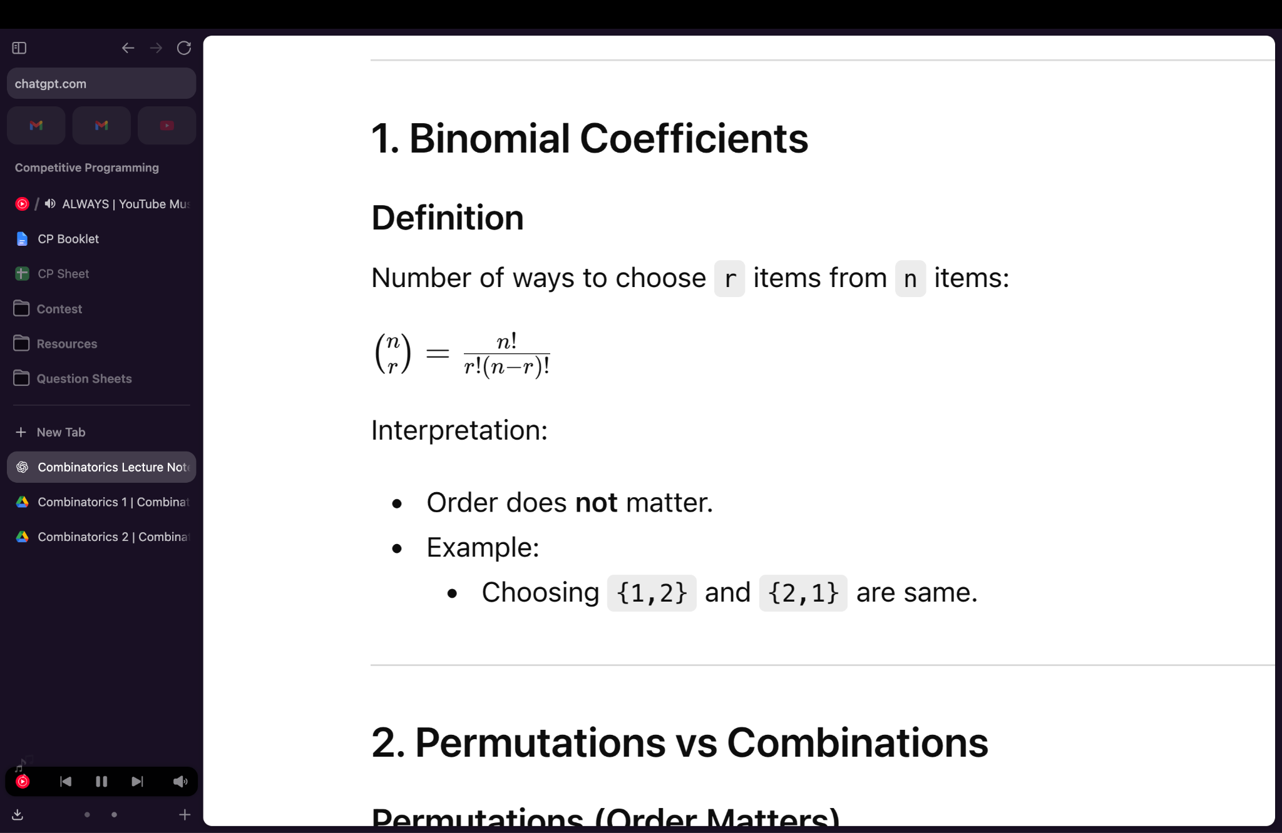
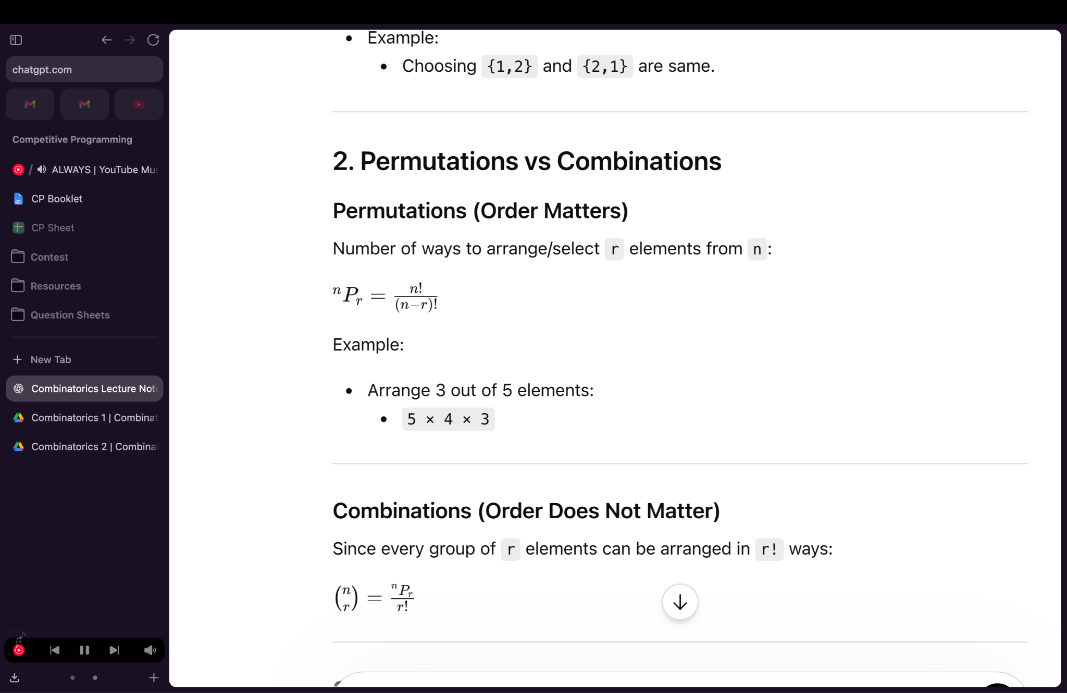
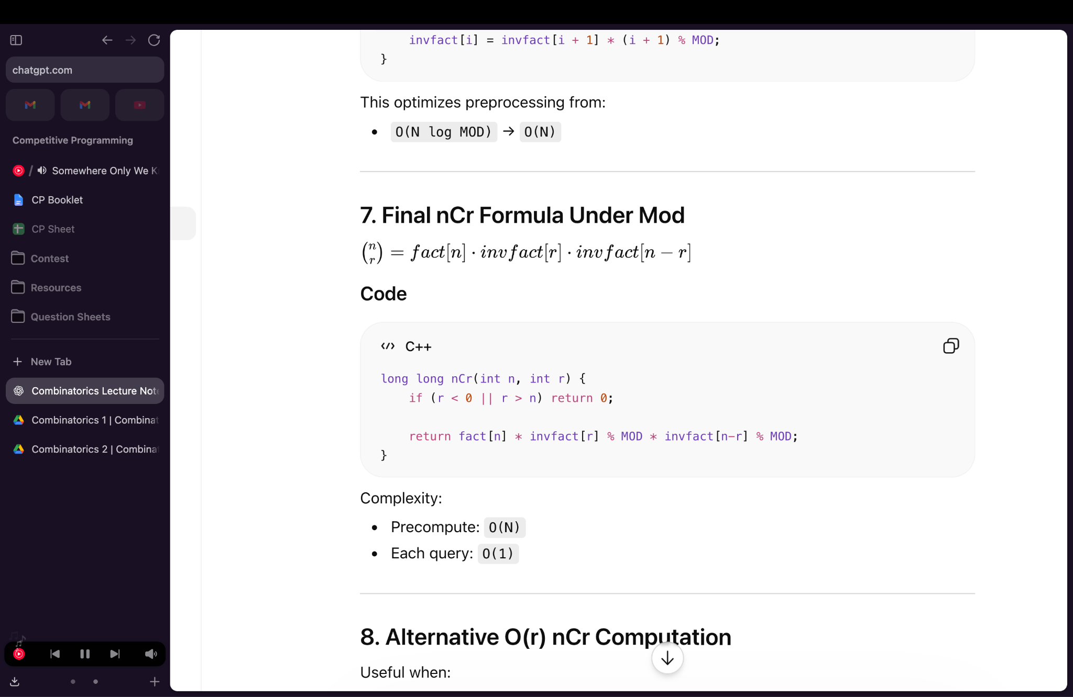
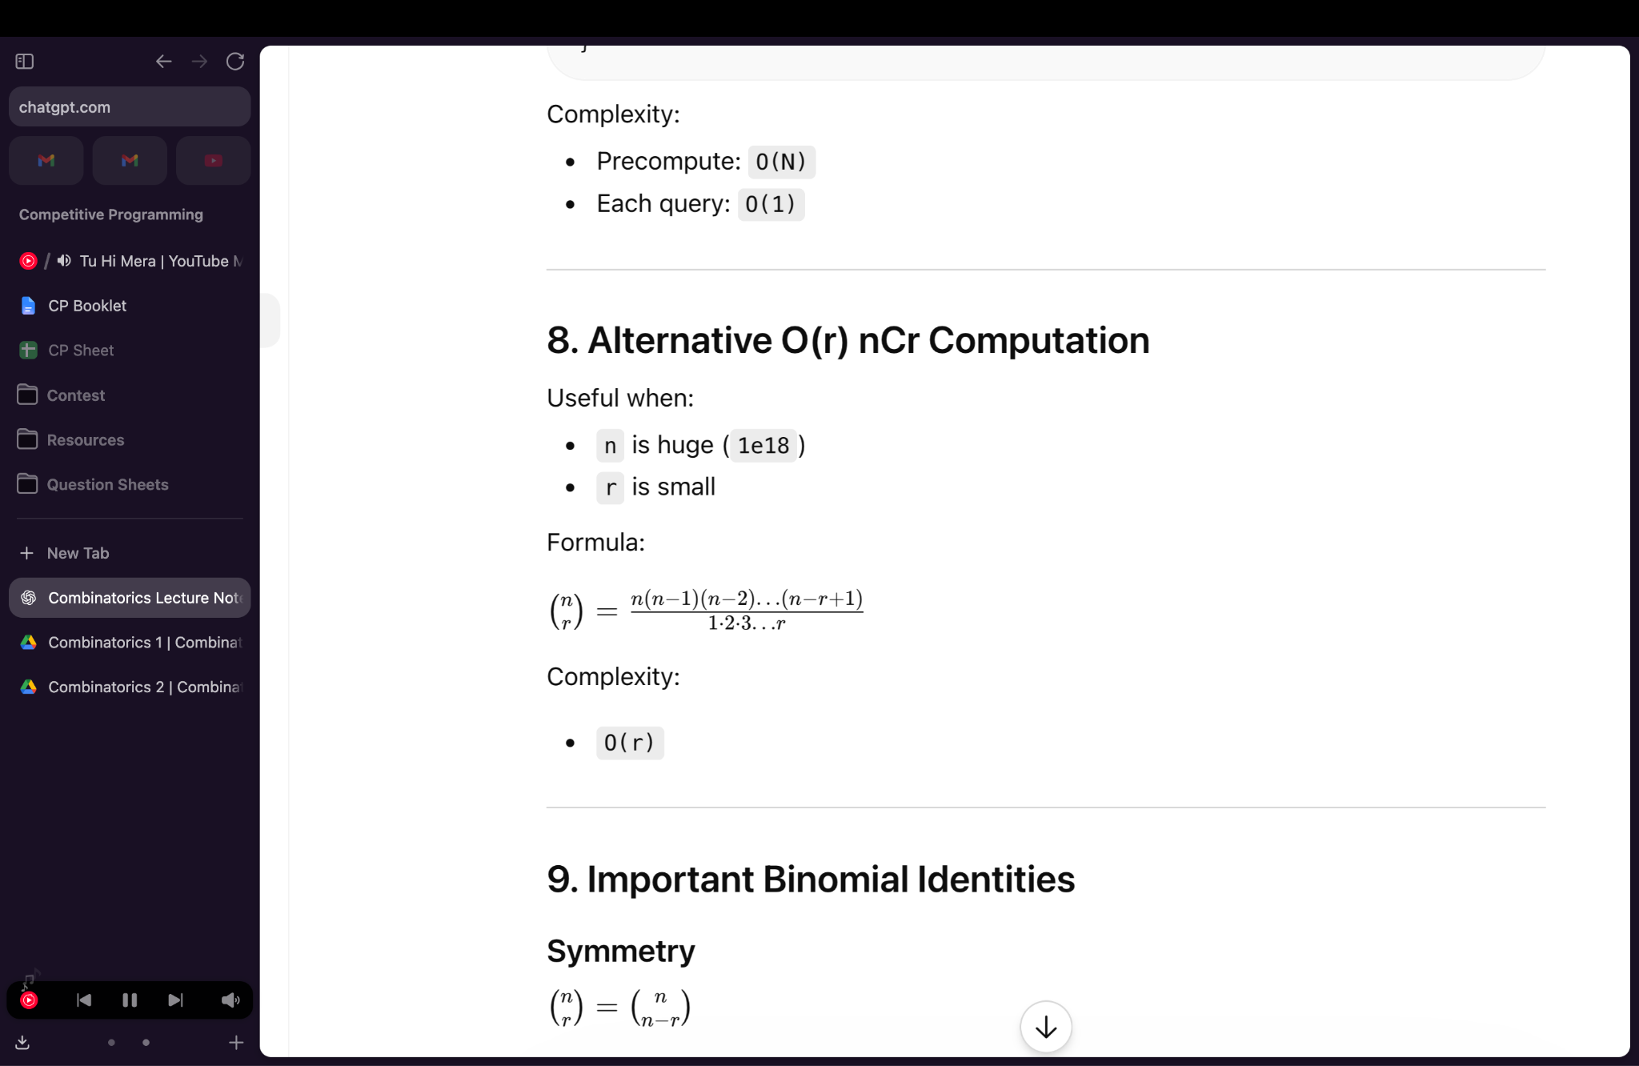


nCr is maximum when r = n/2

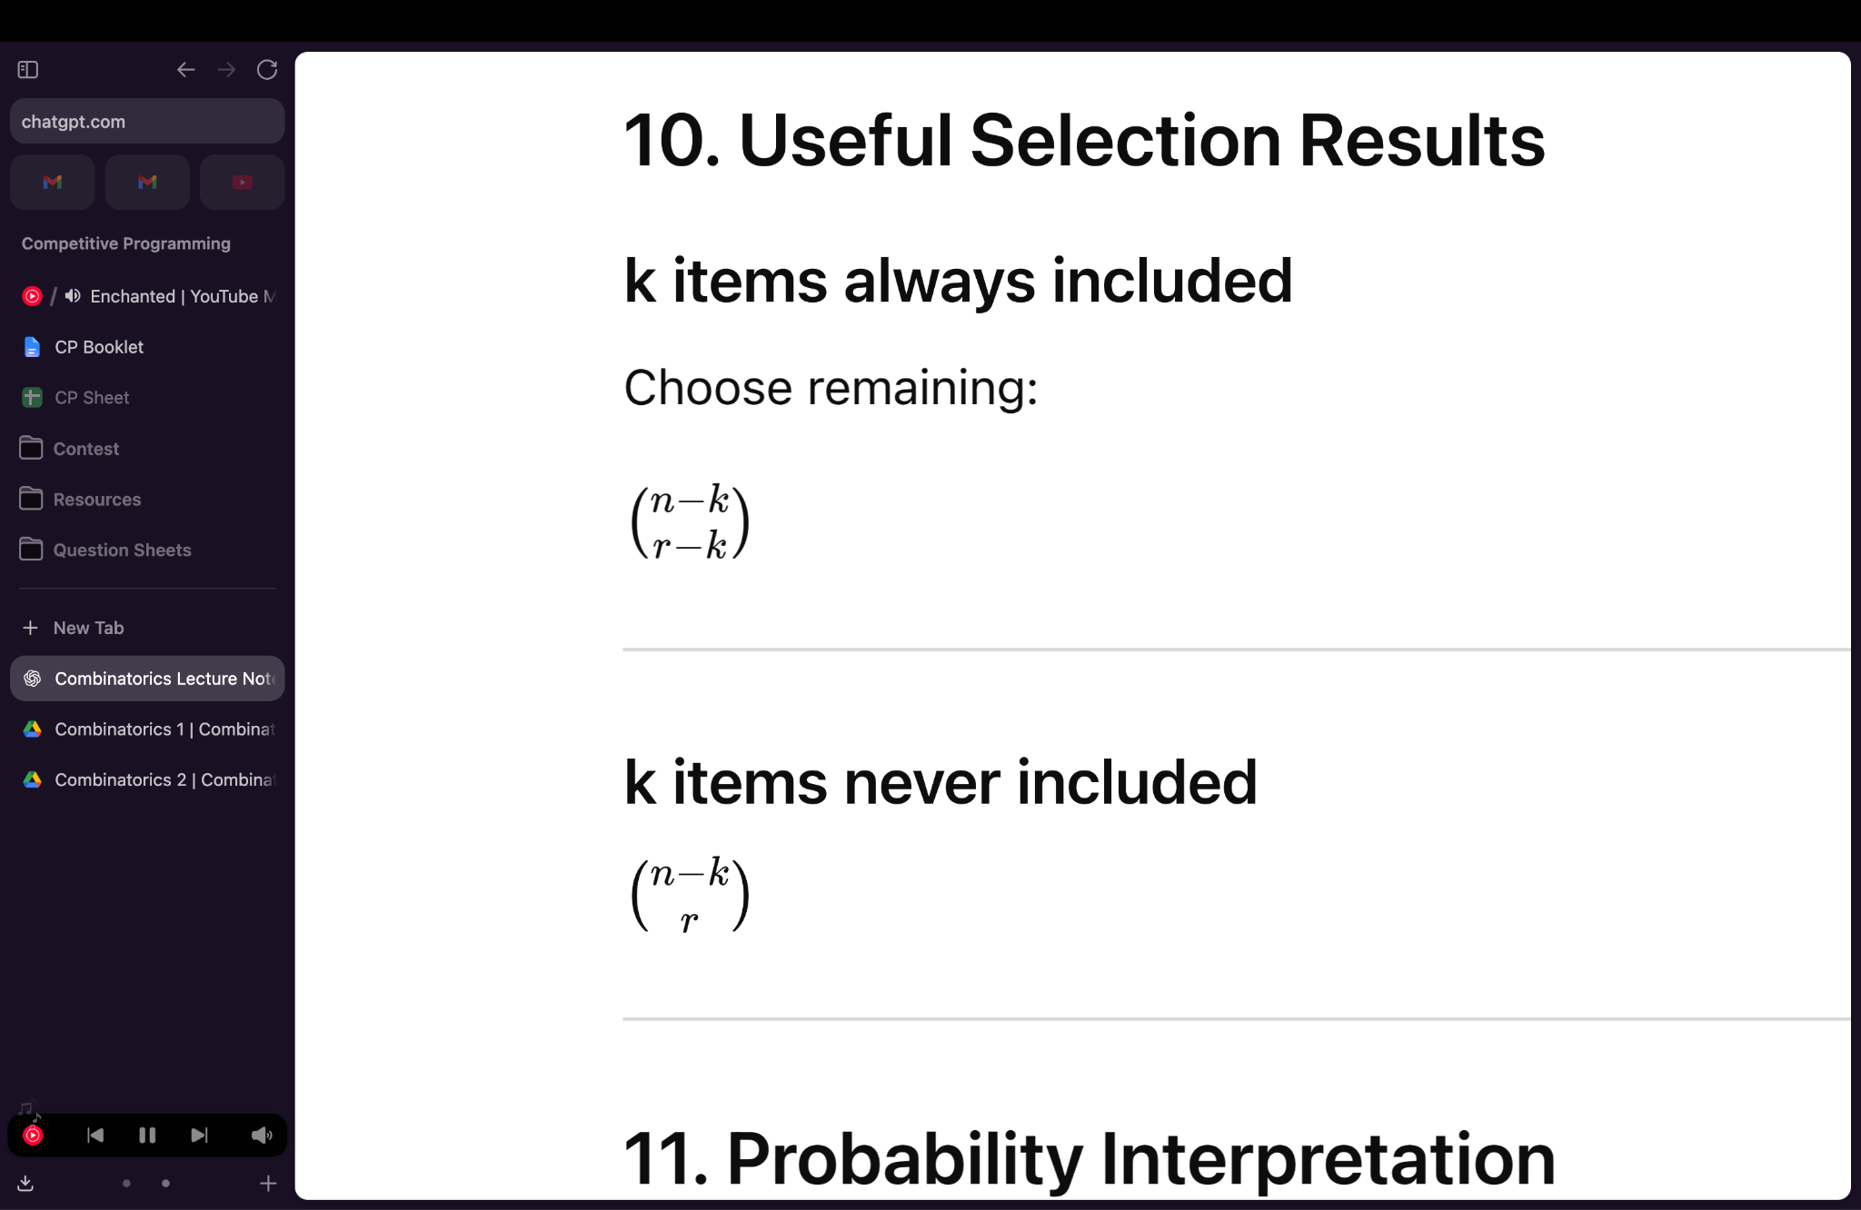
ARRANGEMENTS
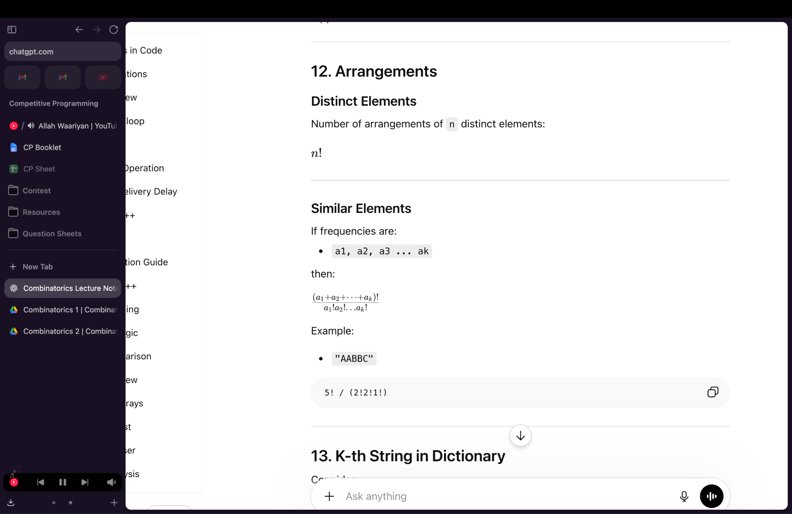

STARS AND BARS
Distribute n identical objects into k distinct boxes
Ex - **|*|**
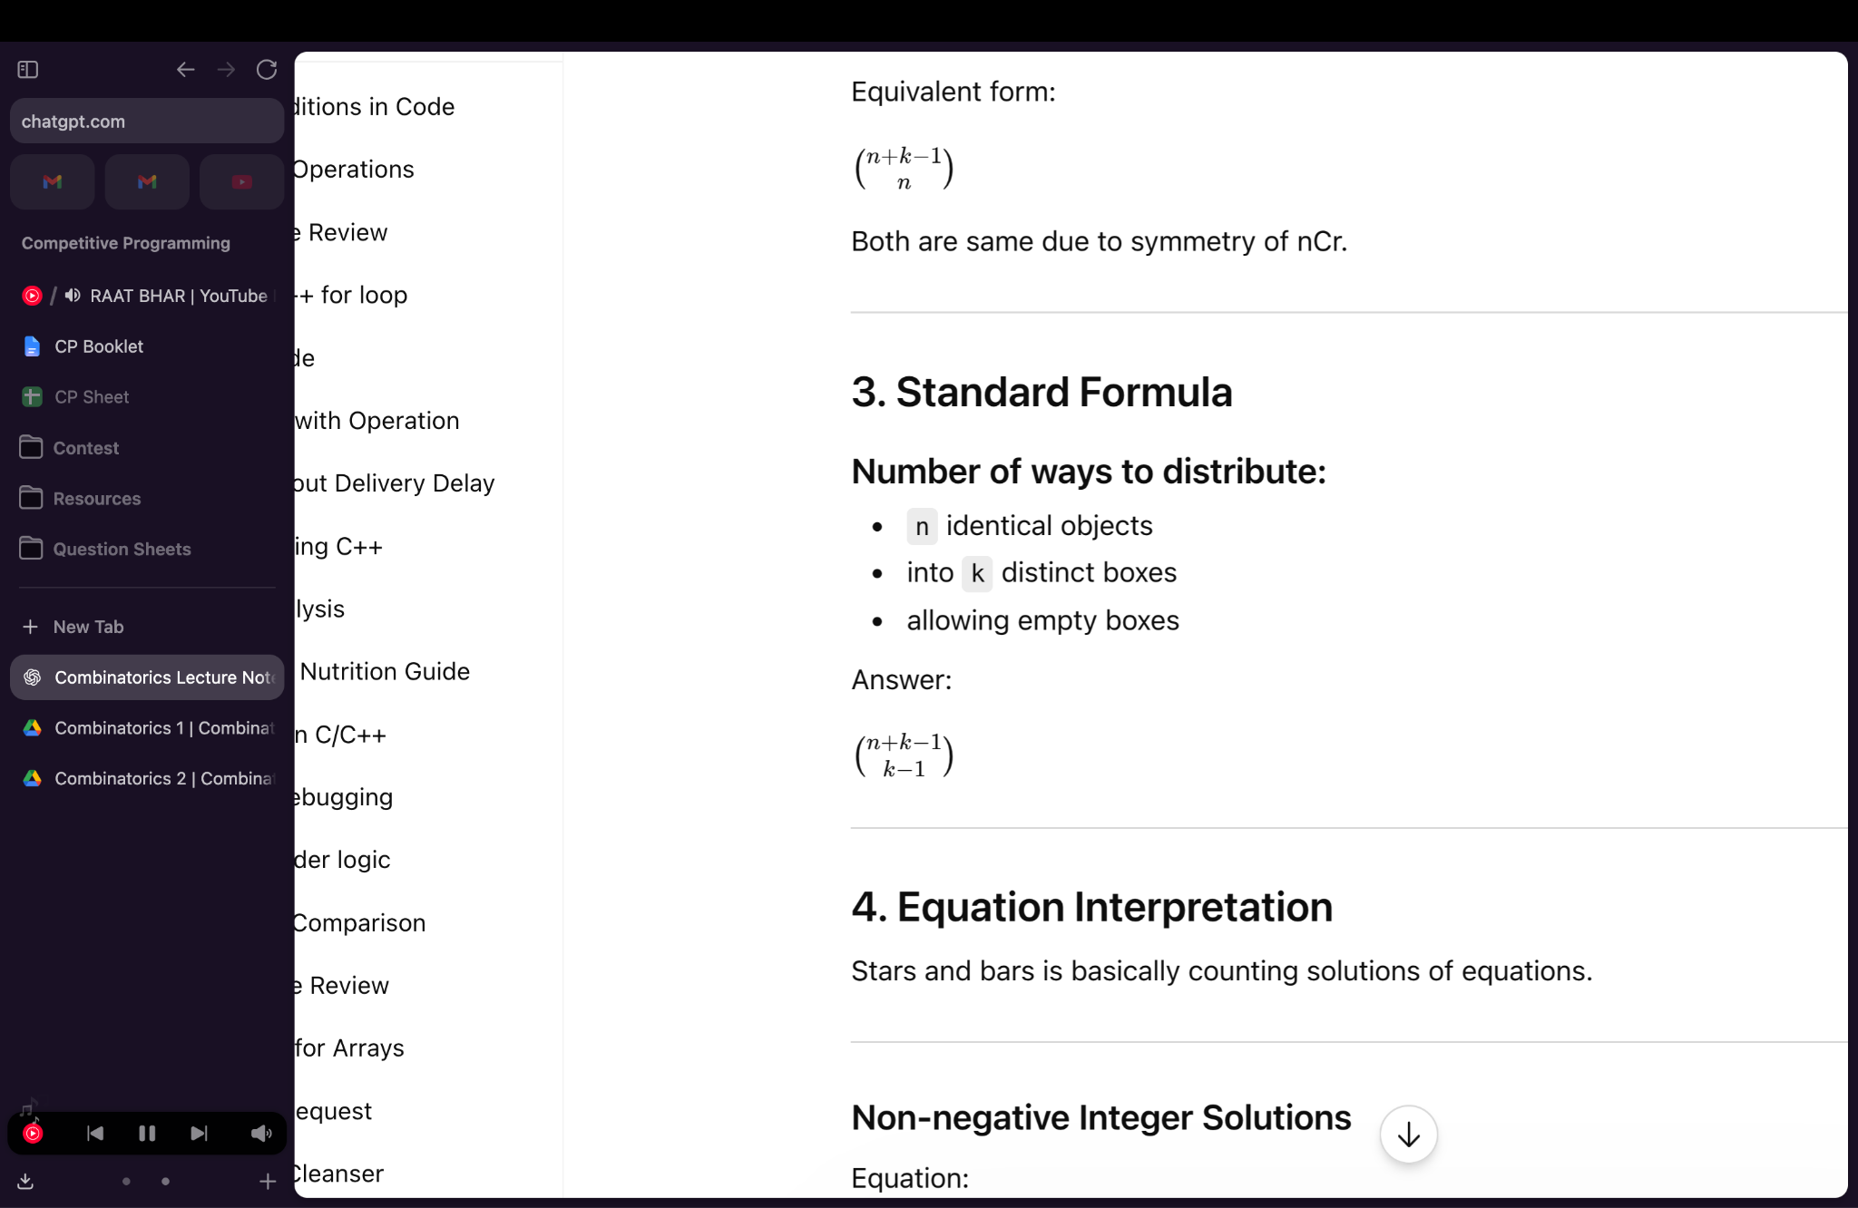
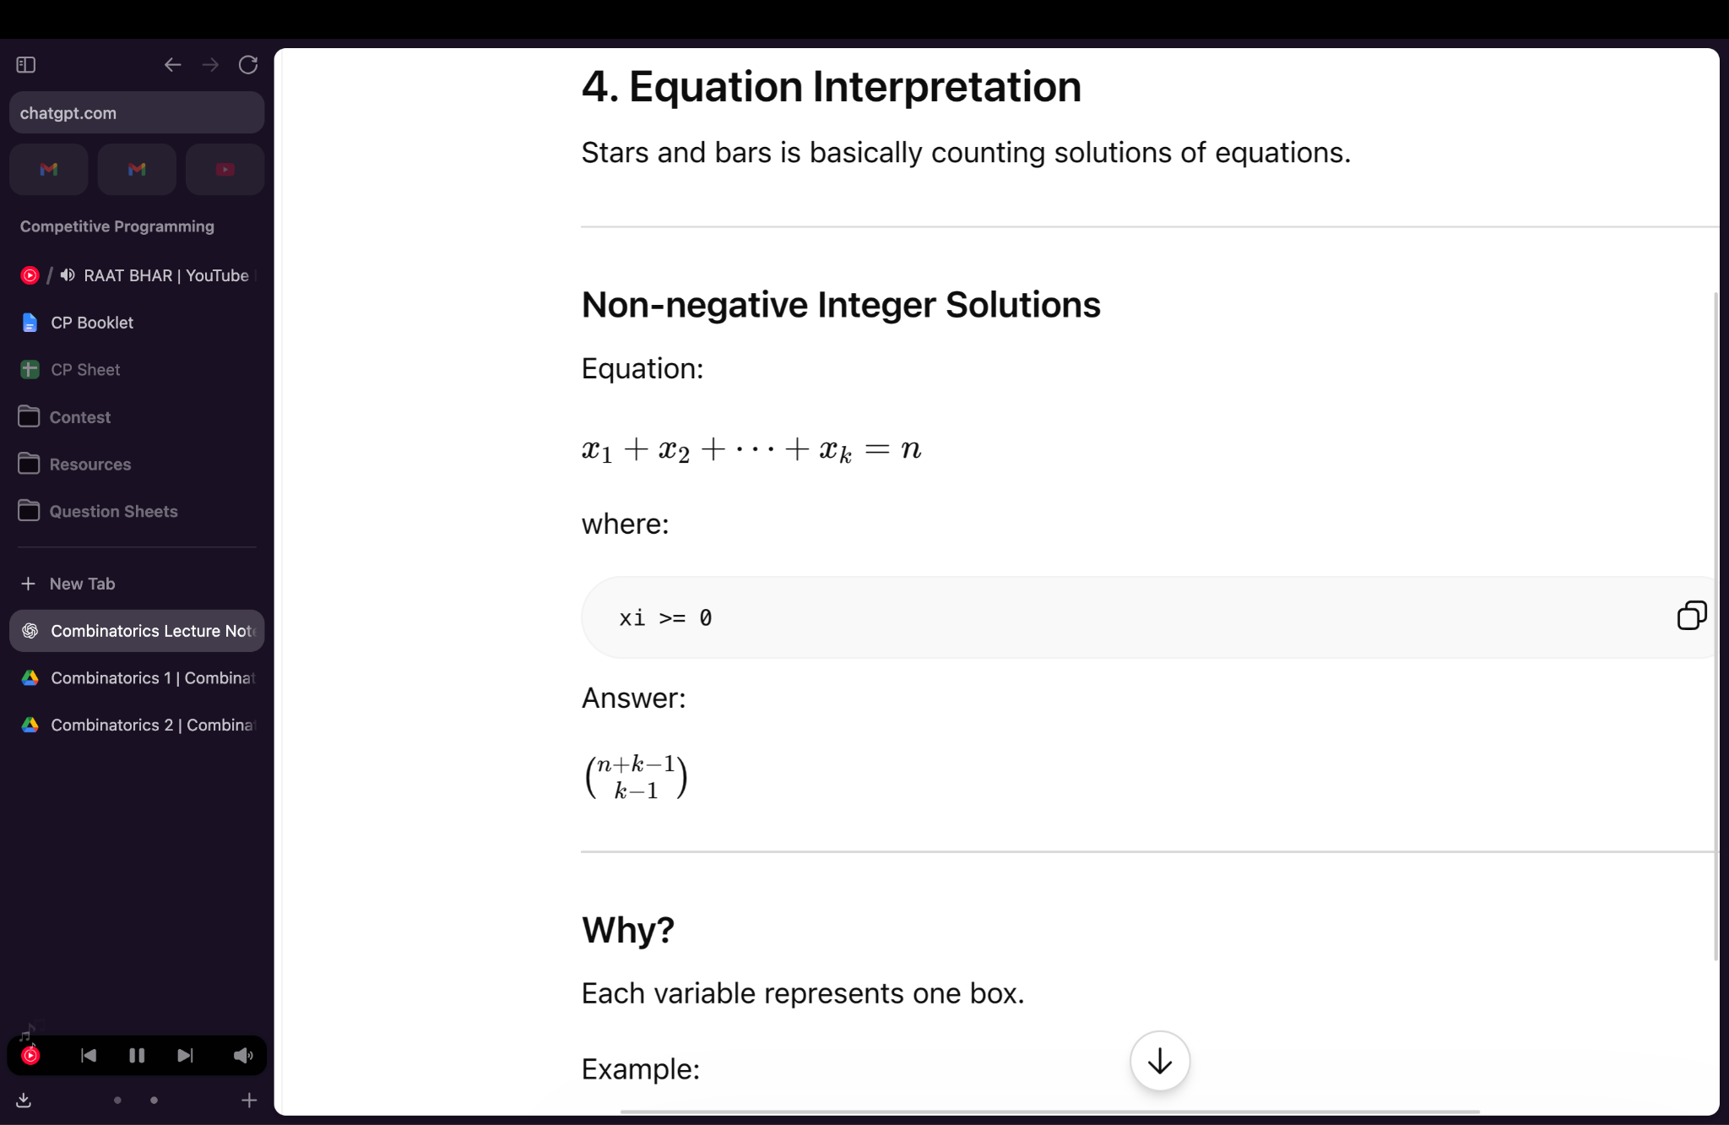

PROBABILITY
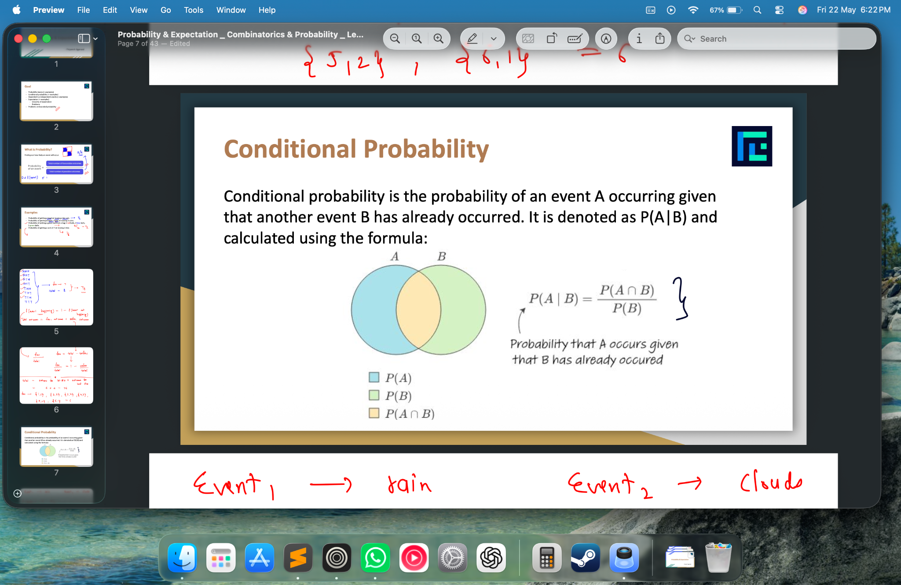

- Independent → P(A ∩ B) = P(A) × P(B)
- Dependent → P(A ∩ B) = P(A) × P(B|A)
- Mutually exclusive → P(A ∪ B) = P(A) + P(B)
P(A ∪ B) = P(A) + P(B) − P(A ∩ B)

EXPECTATION - Weighted average of all outcomes.

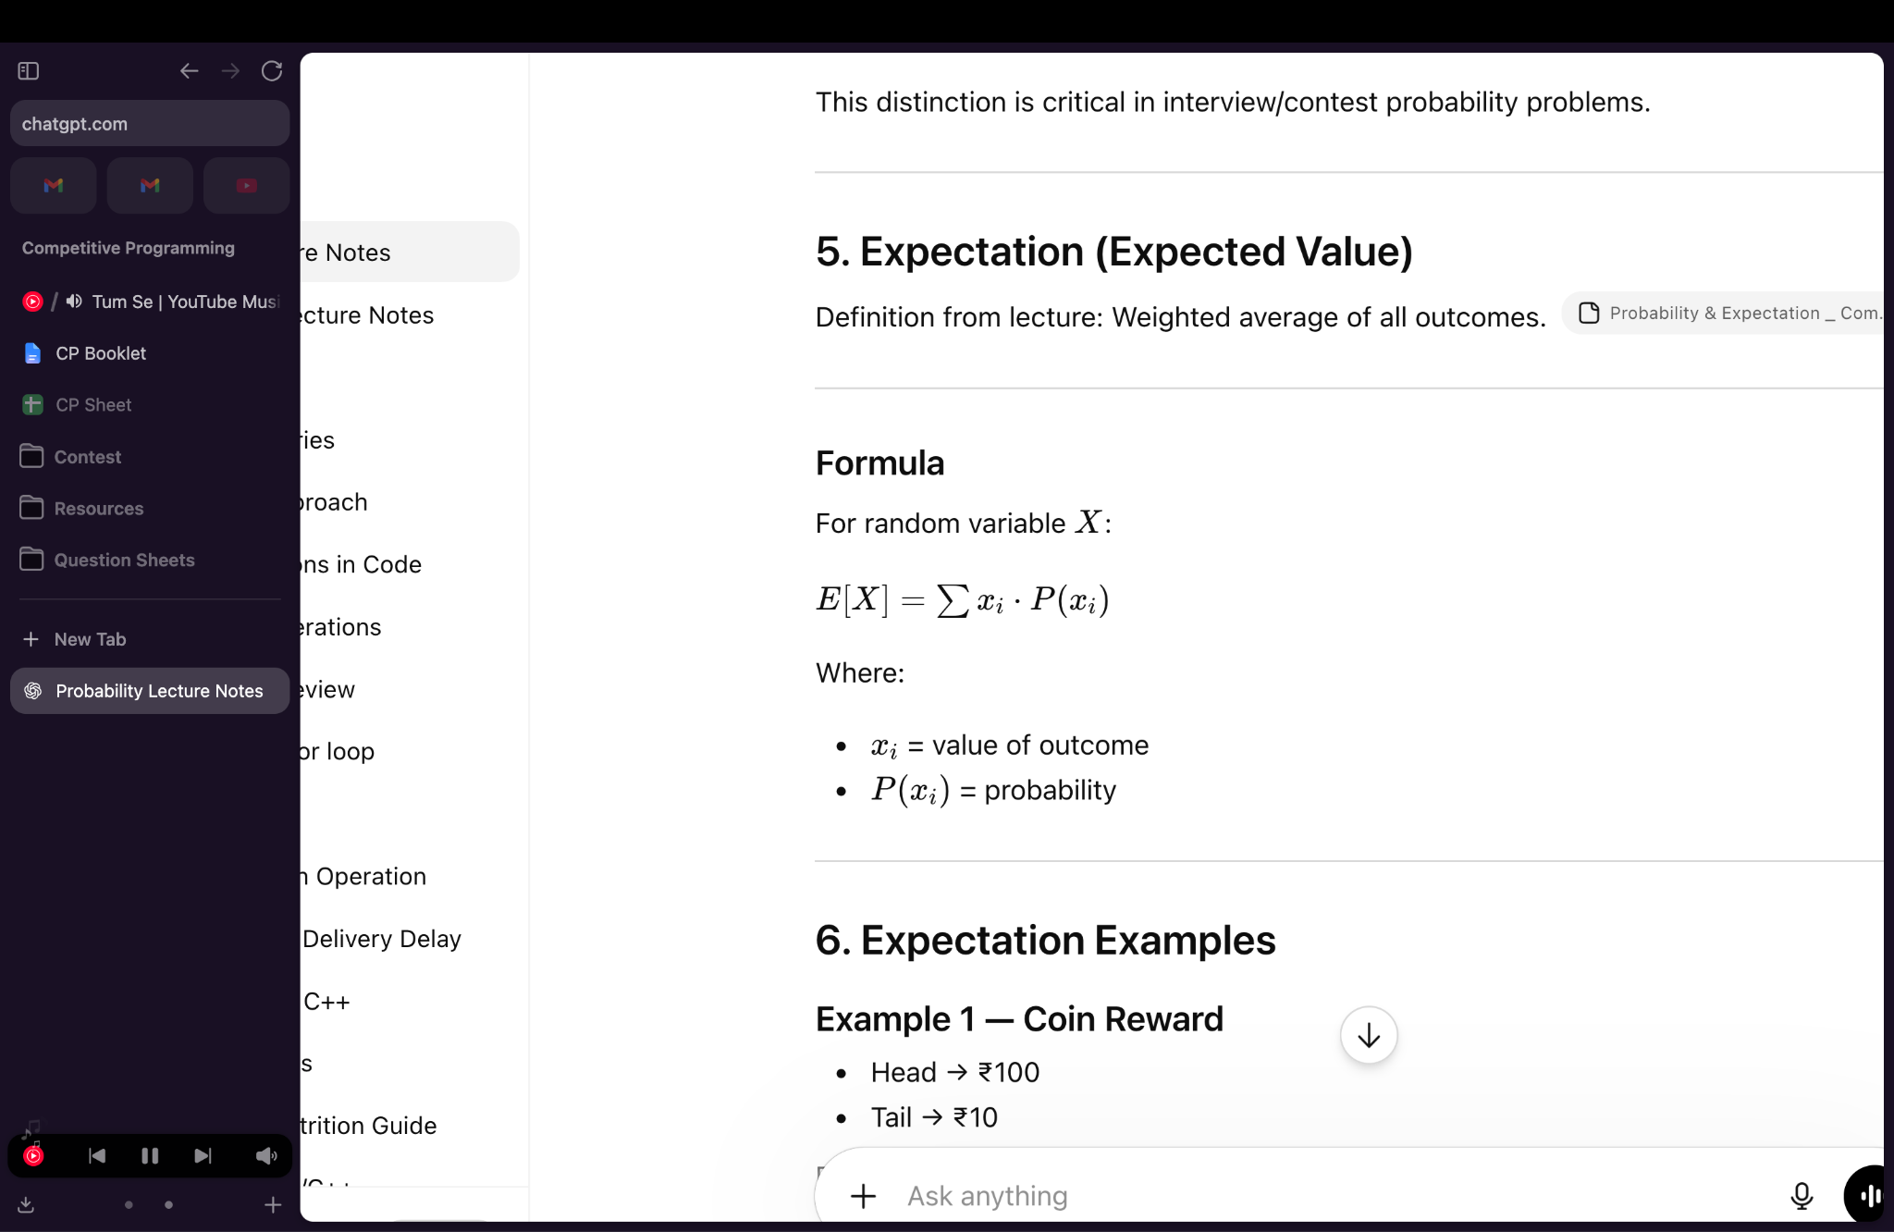

LINEARITY OF EXPECTATION
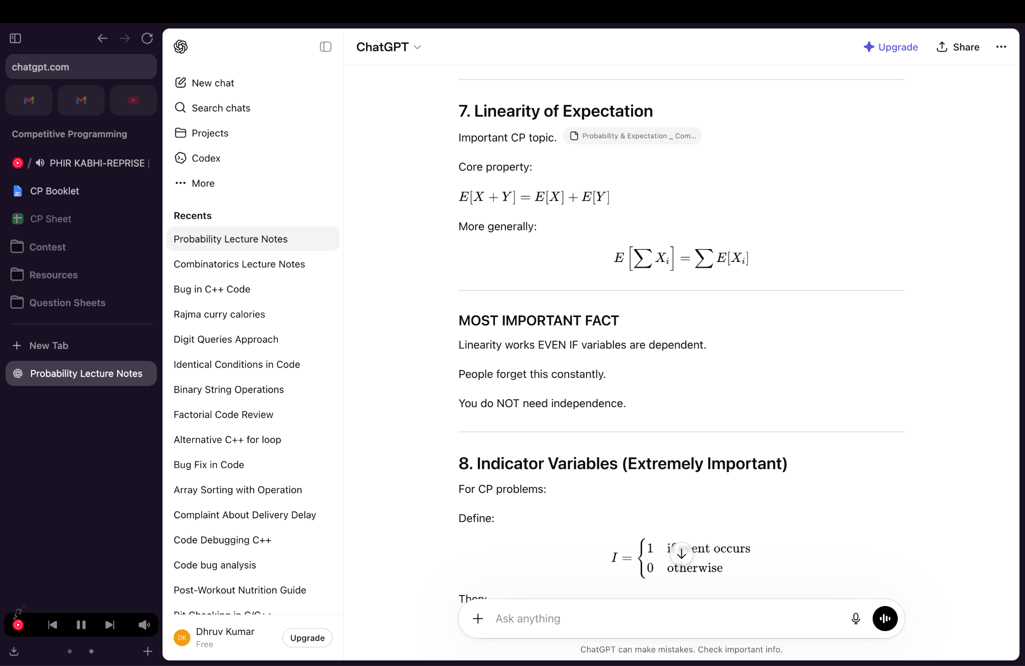
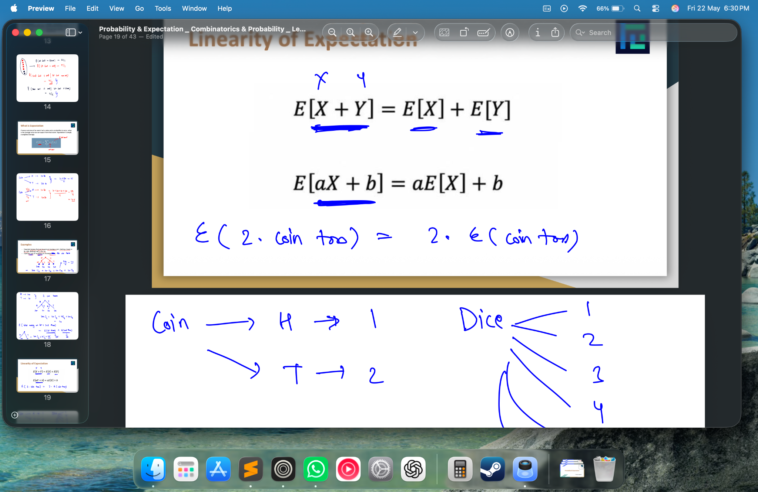
Linearity works EVEN IF variables are dependent.

MODULAR ARITHMETIC

a%b ≤ a/2 – for a ≥ b

(a + b) % MOD = ((a % MOD) + (b % MOD)) % MOD

(a - b) % MOD = ((a % MOD) - (b % MOD) + MOD) % MOD

(a * a) % MOD = ((a % MOD) * (b % MOD)) % MOD

(a / b) % MOD = ((a % MOD) * ((b⁻¹) % MOD)) % MOD

(b⁻¹) % MOD = (b^{MOD-2}) % MOD

Fermat’s Little Theorem (FLT):

If m is a prime and a is not divisible by m:

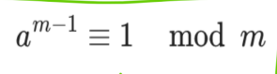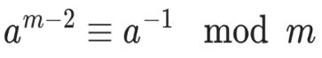

GCD

- gcd(a,b) or __gcd(a,b)

If m is any integer, then gcd(a,b) = gcd(a+m*b,b)

GCD of a,b,c = GCD(a, GCD(b,c))

- gcd(a,0) = a
- gcd(a,1) = 1
- gcd(a,b) = gcd(b,a)
- gcd(a,b) = gcd(a,a+b)
- gcd(a,b) = gcd(b,a % b)
- gcd(a,b) = gcd(b,a-b)
- gcd(a,b) = gcd(a,b−ka)
- gcd(ka,kb) = k·gcd(a,b)
- gcd(a,b) = 1 ⇒ a,b are coprime
- gcd(n,n+1) = 1
- gcd(a,b)≤ min(a,b)
- gcd(a^{m},a^{n})=a^{min(m,n)}

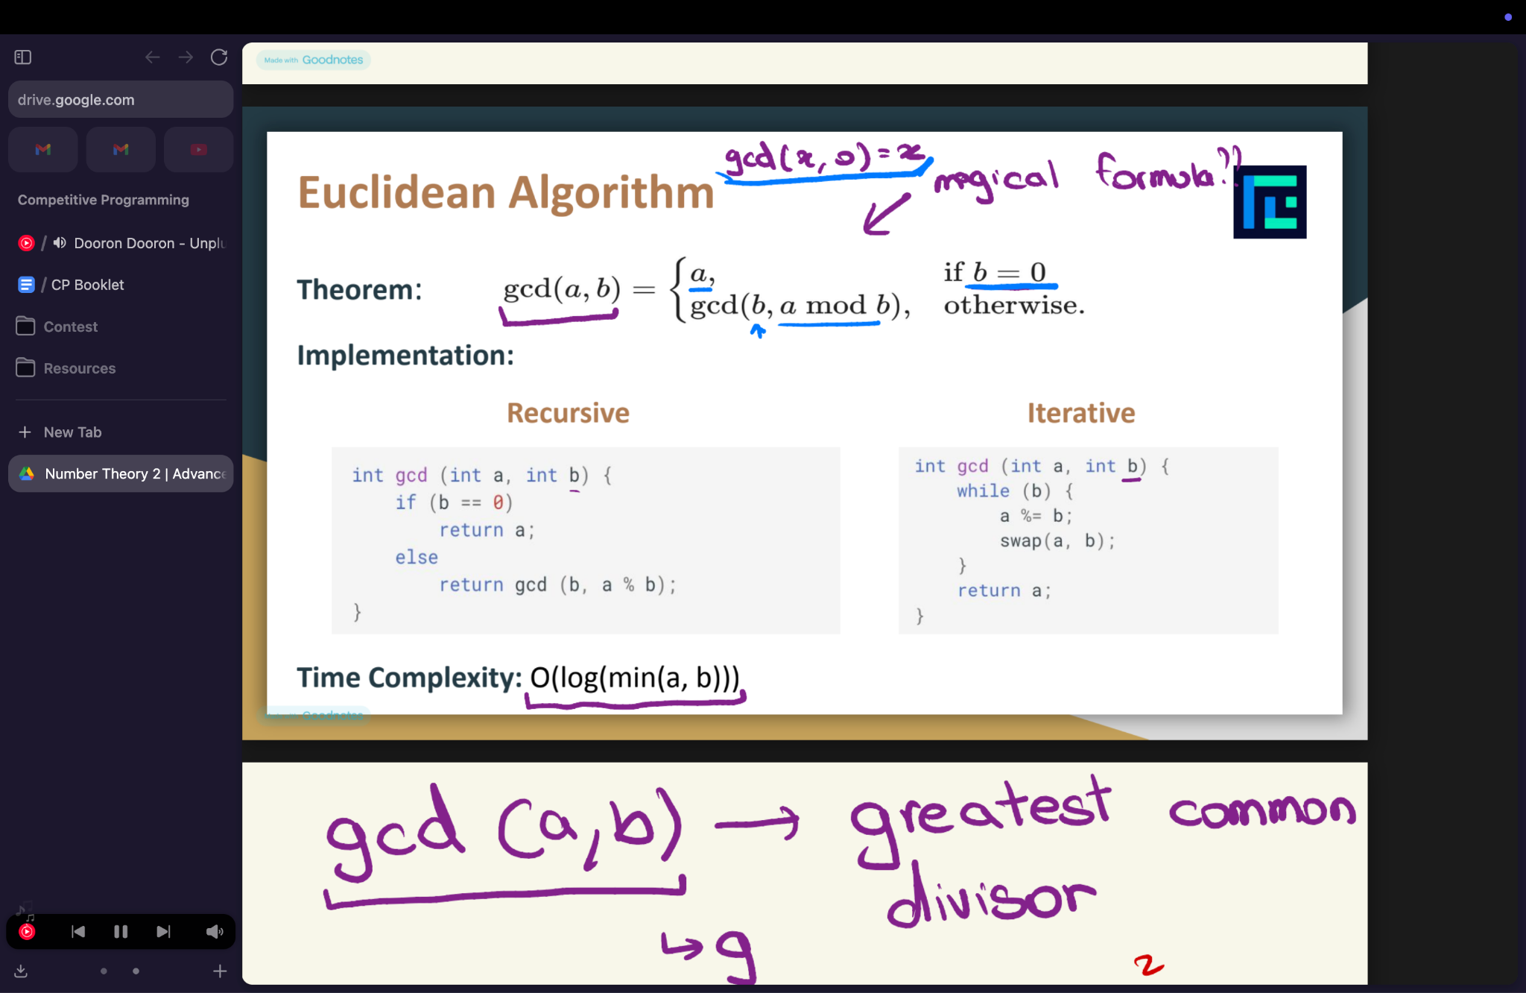

LCM

LCM(a,b) * GCD(a,b) = a * b

- lcm(a,0)=0
- lcm(a,1) = a
- lcm(a,b) ≥ max(a,b)
- lcm(a,b) = max(a,b) if one divides the other
- IF gcd(a,b) = 1 then lcm(a,b) = a * b
- lcm(a^{m},a^{n})=a^{max(m,n)}

Pigeonhole principle states that if n pigeons are in m holes and n > m, then at least one hole has more than one pigeon.

DIVISIBILITY RULE

2 - last digit is one of the following: 0, 2, 4, 6, or 8

3 - sum of its digits is divisible by 3.

4 - last two digits are divisible by 4

5 - last digit of that number is either 0 or 5.

6 - number is divisible by both 2 and 3.

7 - Double last digit and subtract from rest. If result divisible by 7 or 0 → ✅

8 - last three digits of the number are divisible by 8.

9 - Sum of digits divisible by 9

10 - Ends with 0

11 - Difference between sum of odd and even positioned digits is 0 or multiple of 11

12 - Divisible by 3 and 4

25 - Last 2 digits 00, 25, 50, 75

100 - Last 2 digits 00

BIT MANIPULATION

Left shift (<<) - Multiplies by 2
Right shift (>>) - Divides by 2
AND (&) - 1 if both bits are 1
OR (|) - 1 if any bit is 1
XOR (^) - 1 if bits differ
NOT (~) - Inverts all bits

After subtracting 1 from a number, all bits from the rightmost set bit onward get toggled (including that set bit).

After adding 1 to a number, all bits from the rightmost unset bit onward get toggled (including that unset bit).

COMMON BIT TRICKS

If A^B = C , then A^C = B and B^C = A
A & B ≤ MIN(A,B)
A | B ≥ MAX(A,B)
A + B = (A ^ B) + 2(A & B)
A + B = (A | B) + (A & B)

IF no of set bits in A = X
IF no of set bits in B = Y
No. of set bits in (A^B) = Z
Z is even if X+Y is even
Z is odd if X+Y is odd

log2(n) gives the exponent of the highest power of 2 less than or equal to n

Check the parity:
if(x & 1) == 1 // x is odd
== 0 // x is even

Count number of bits in a number:
log2(n)+1;

Check the kth bit:
if(x & (1<<k)) != 0 // kth bit is set
== 0 // kth bit is not set

Set ith bit:
x = x | (1 << i);

Unset the Kth bit
x = x & ~(1<<k)

Toggle ith bit:
x = x ^ (1 << i);

Check power of 2:
if((x & (x-1)) == 0) // YES
> 0 // NO

Turn off the rightmost set bit:
n = n & (n - 1)

//all bits after rightmost set bit gets toggled including that set bit after subtraction

Get the rightmost unset bit: // 0 based
X = __builtin_ctz((~n) & (n + 1));

//all bits after rightmost unset bit gets toggled including that unset bit after addition

Get the Kth bit: (1 based)
X = (n >> (k-1)) & 1

FORMULA - (a ⊕ (a & b)) + (b ⊕ (a & b)) = a ⊕ b

__builtin_popcount() OR __builtin_popcountll() - count the number of set bits

__builtin_clz() OR __builtin_clzll() - count the leading zeros

__builtin_ctz() OR __builtin_ctzll() - count the trailing zeros

__builtin_ffs(x) - Finds the position of the first (lowest) set bit.// 1-based

__builtin_parity(x) - Returns parity of number of set bits.
Returns 1 → odd number of set bits
Returns 0 → even number of set bits

COUNT THE SET BITS

int countSetBits(int n) {
int cnt = 0;
while (n > 0) {
n = n & (n - 1); // removes lowest set bit
cnt++;
}
return cnt;
}

LOWEST SET BIT POSITION

int lowestSetBitPos(int n) {
int pos = 0; // 0 based index
while ((n & 1) == 0) {
n >>= 1;
pos++;
}
return pos;
}

HIGHEST SET BIT POSITION

int highestSetBitPos(int n) {
int pos = -1; // 0 based
while (n > 0) {
pos++;
n >>= 1;
}
return pos;
}

LOWEST UNSET BIT POSITION

int firstUnsetBitIndex(int n) {
int idx = 0;
while (n & 1) {
n >>= 1;
idx++;
}
return idx;
}

HIGHEST UNSET BIT POSITION

int lastUnsetBitIndex(int n) {
for (int i = 31; i >= 0; i--) {
if (((n >> i) & 1) == 0)
return i;
}
return -1; // all bits are set (n == -1)
}

HIGHEST UNSET BIT AMONG SIGNIFICANT BITS
int highestUnsetBit(int n) {
int pos = 0;
int ans = -1;

while (n) {
if ((n & 1) == 0)
ans = pos;

pos++;
n >>= 1;
}

return ans;
}

GENERATE ALL SUBSET USING BITMASKING

void generateSubsets(vector<int>& a) {
int n = a.size();

for (int mask = 0; mask < (1 << n); mask++) {
for (int i = 0; i < n; i++) {
if (mask & (1 << i)) {
cout << a[i] << " ";
}
}
cout << '\n';
}
}

BITSET

bitset<n> name;

n is the number of bits to allocate, and name is the name assigned.

bitset<size> variable_name("BINARY_STRING");

bitset<size> variable_name(DECIMAL_NUMBER)` - Bitset will represent the given decimal number in binary form.

count() :- Count the number of set bits in bitset.

flip() :- Flip the bit at given index.

any() , none() , all() :- Checks whether any / none / all bits are set.

set() :- Set the bit at given index to 1.
reset() :- Set the bit at given index to 0.
size():- Returns the size of bitset
test()` - tests whether the bit at a given index is set or not

Encode and decode

encoded = popcount * BASE + value

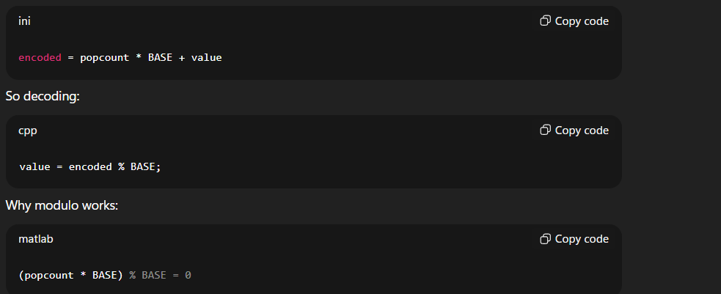

encoded = 2 * 10001 + 5 = 20007
20007 % 10001 = 5

Original value recovered exactly.

BASE must be strictly greater than the maximum possible value of the secondary key. Secondary means value here

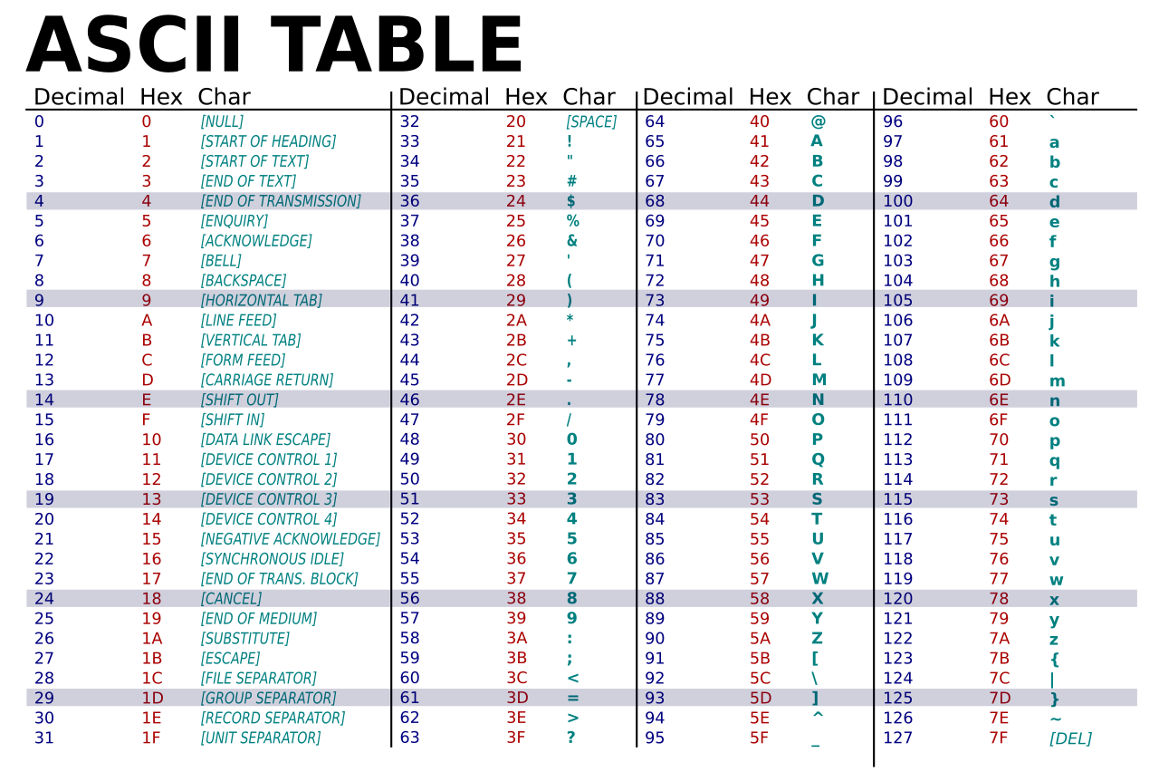

No of Substring - n*(n+1) / 2

Power of x in n!= n/x + n/x² + n/x³ +...

Int power_in_factorial(int n, intp) {
int cnt = 0;

while (n > 0) {
n /= p;
cnt += n;
}

return cnt;
}

Power of x in n

int power(int n, int x) {
int cnt = 0;
while (n % x == 0) {
n /= x;
cnt++;
}
return cnt;
}

smallest multiple of i ≥ L == ((L + i - 1) / i) * i

Sort map by values

map<int, int> mp = {{1, 5}, {2, 3}, {3, 8}};

// move to vector
vector<pair<int, int>> v(mp.begin(), mp.end());

// sort by value using lambda
sort(v.begin(), v.end(), [](const pair<int,int> &a, const pair<int,int> &b) {
return a.second < b.second; // ascending by value
});

Rotational Symmetry - 90° clockwise
(i, j) -> (j, n - i - 1)

Mirror Symmetry - Left to Right
(i, j) -> (i, n - j - 1)

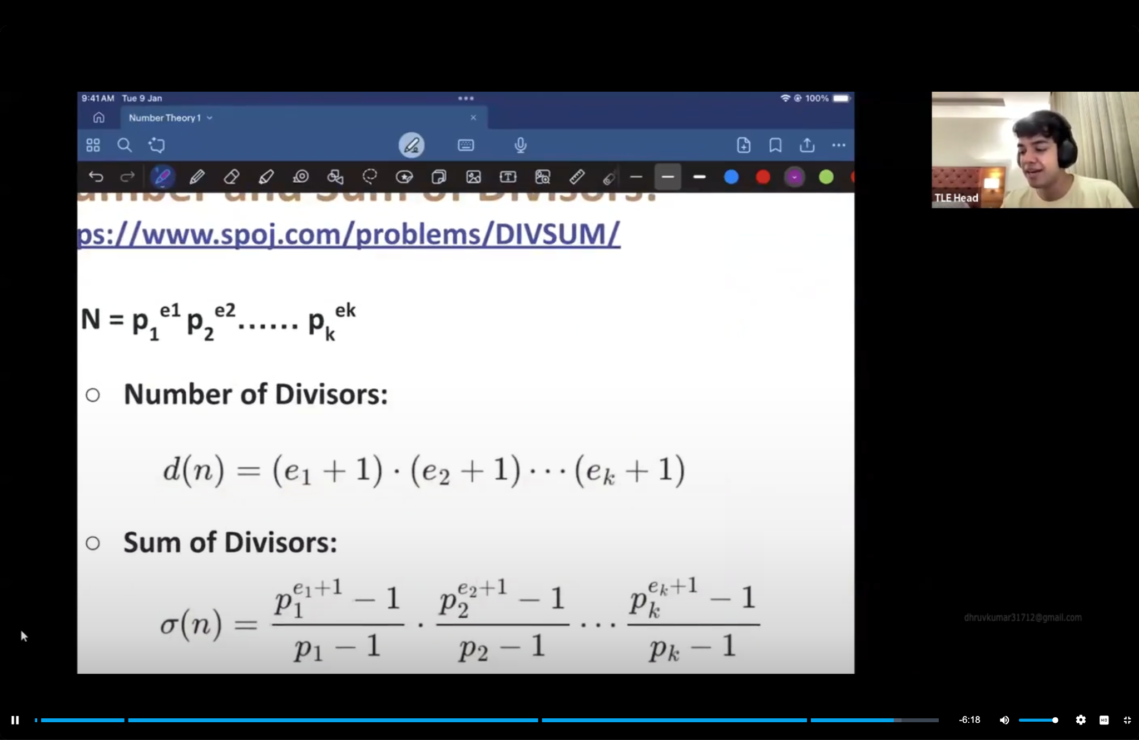

3 consecutive odd number can never have common factor

Euler’s Totient Function

𝜙(N) = number of integers between 1 and N inclusive, which are coprime to N

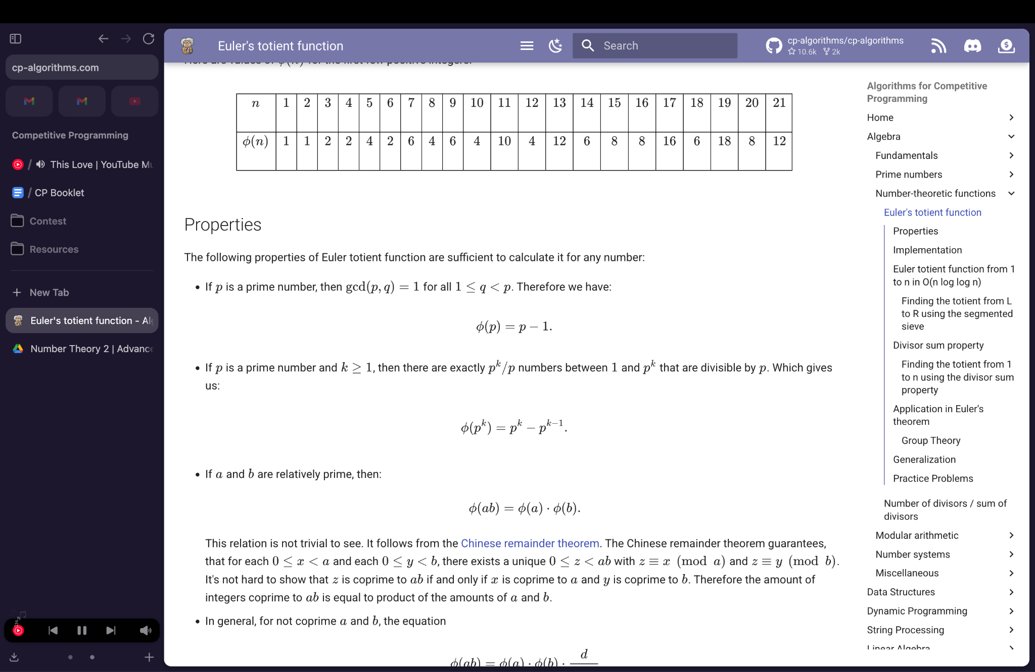
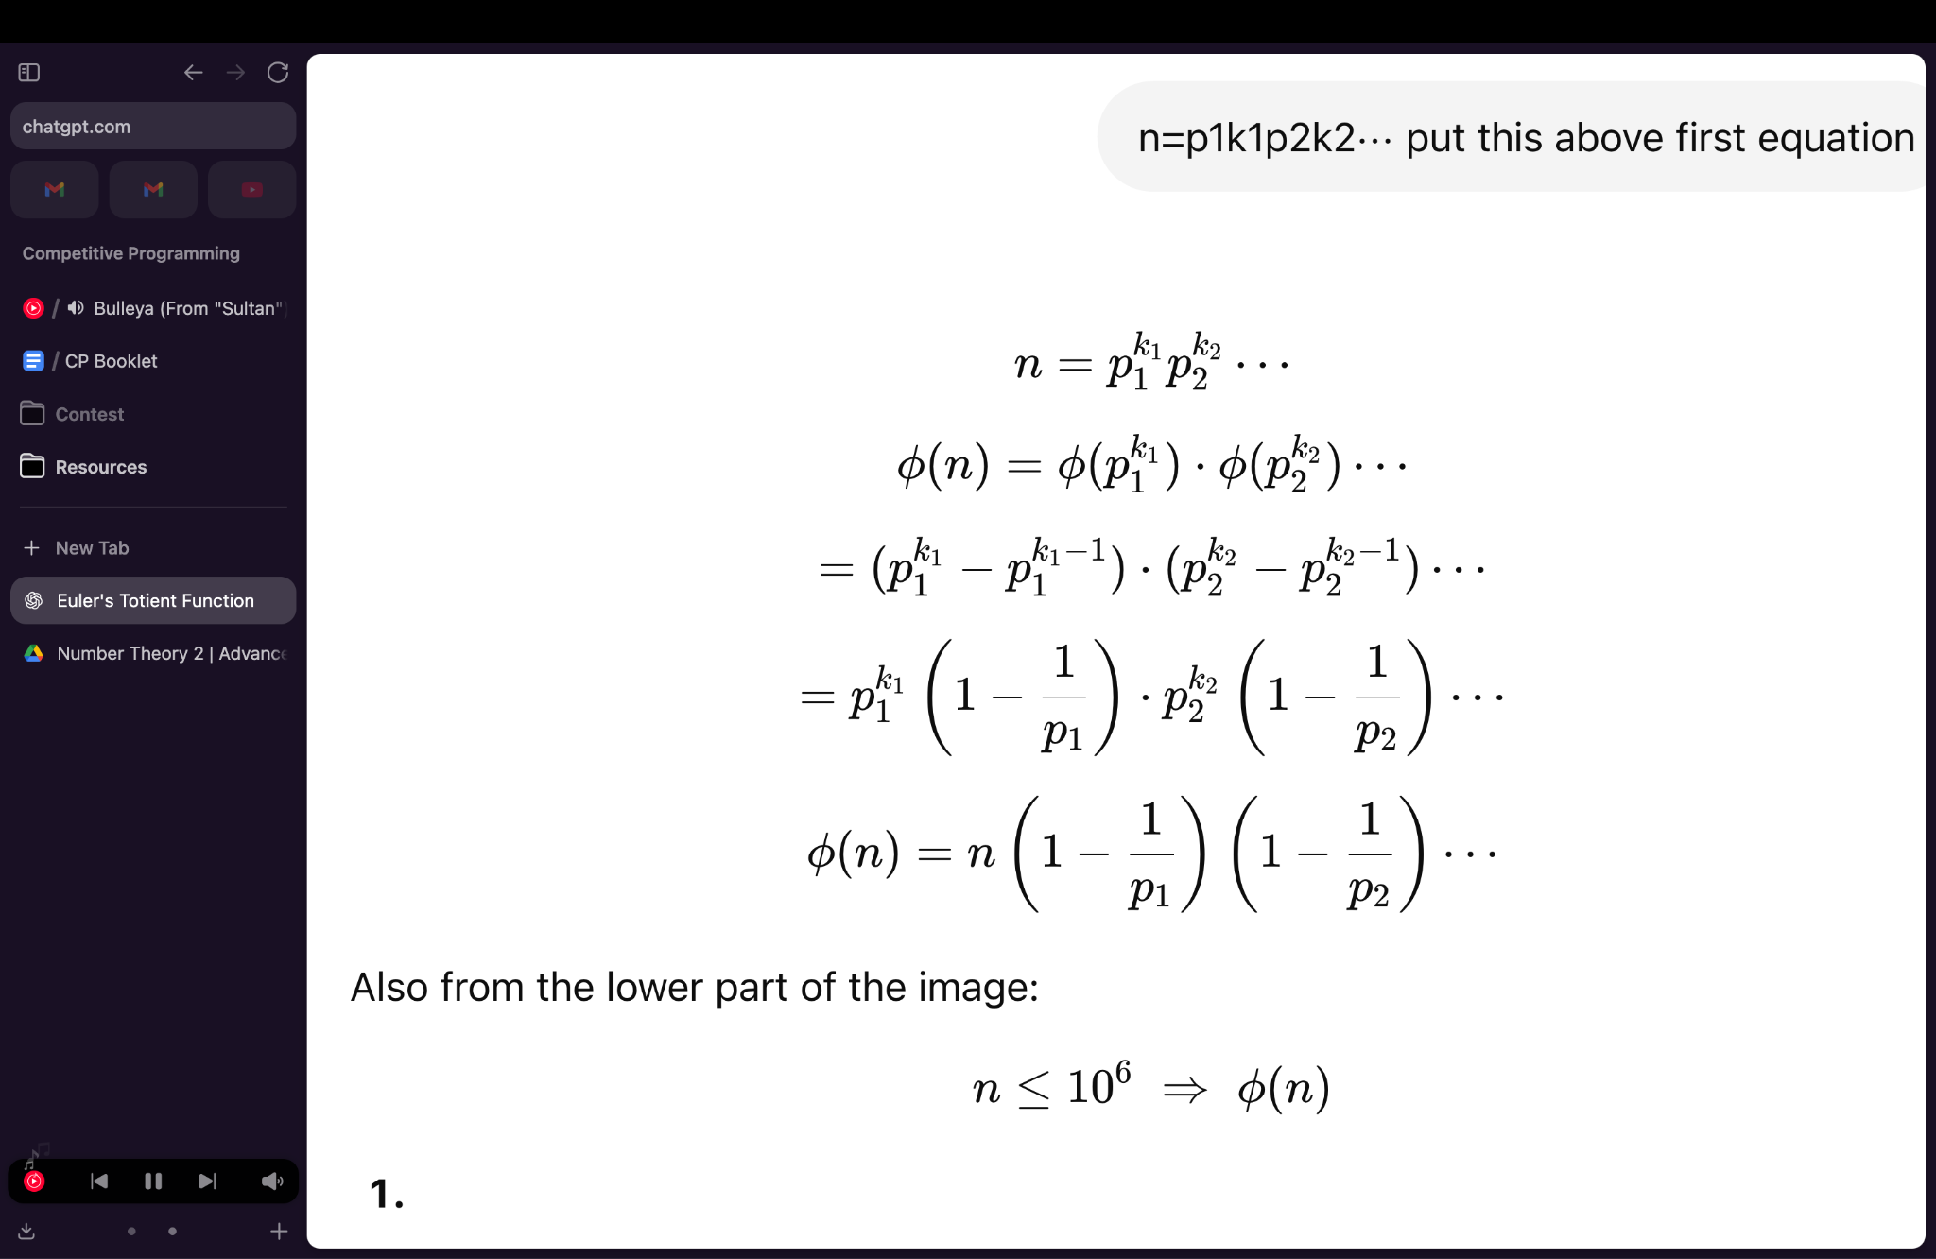

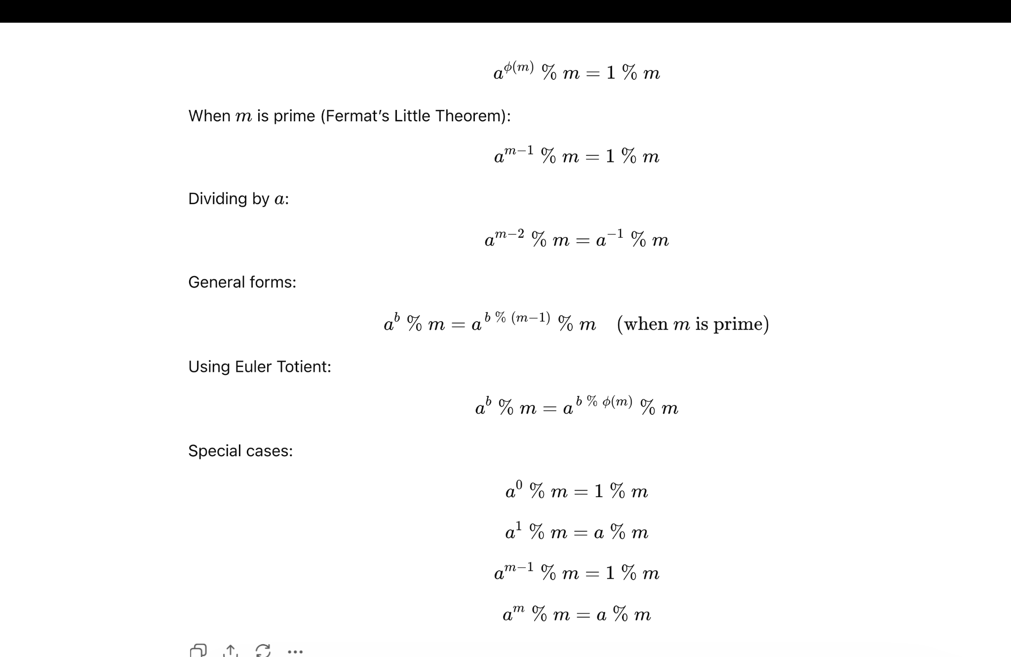
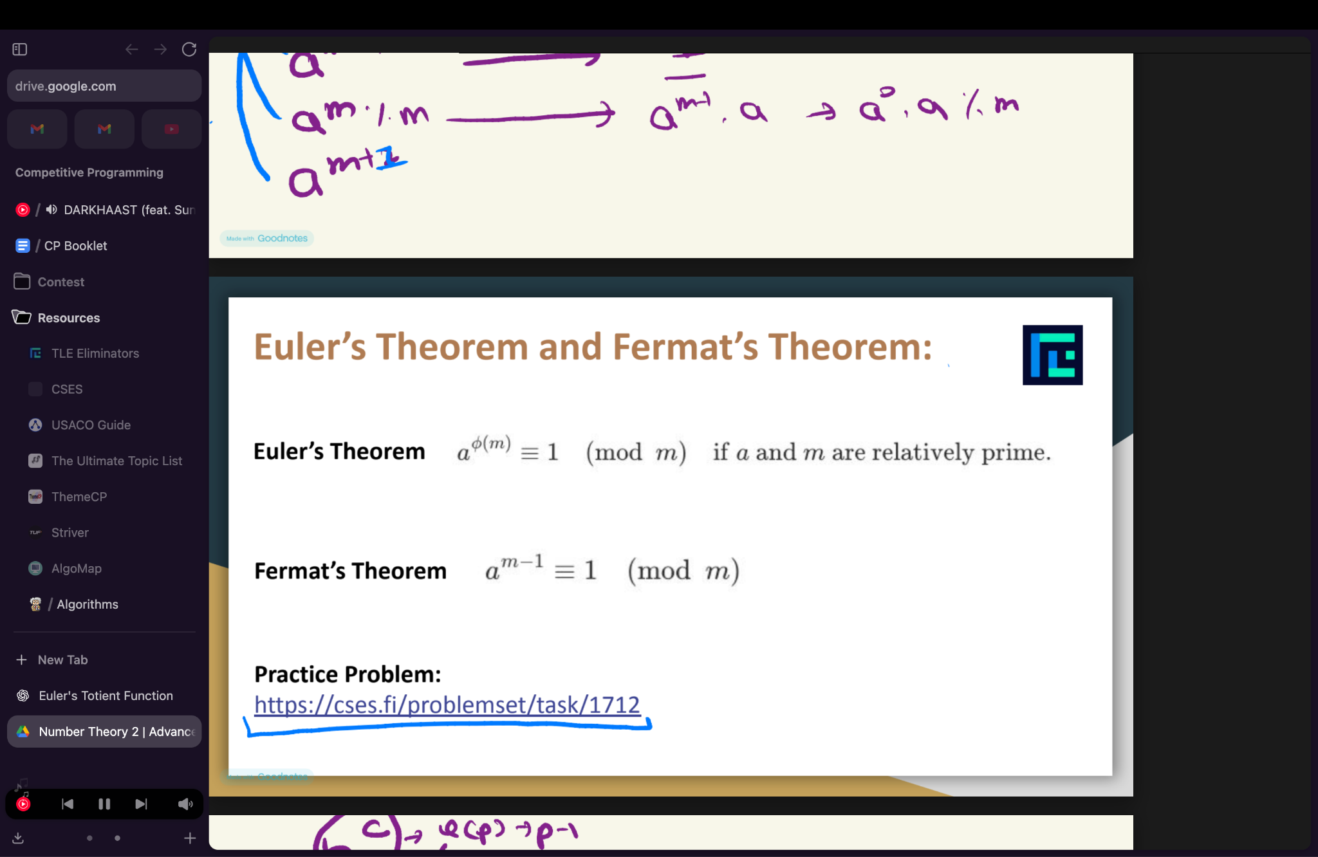
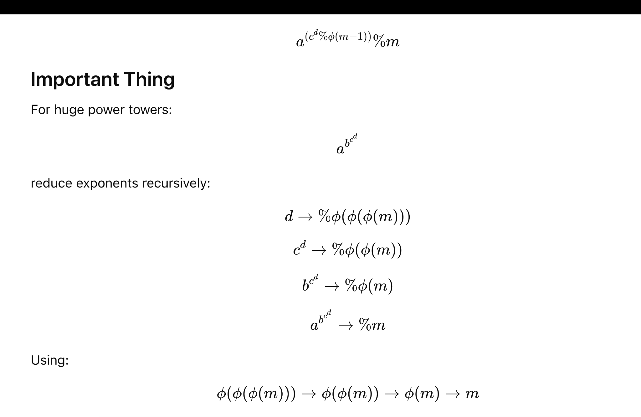

The number of factors of N are approx ∛N

DEPTH FIRST SEARCH

vector<int> adj[N];

void dfs(int node, int parent)
{

for(auto child : adj[node])
{
if(child == parent) continue;

dfs(child, node);
}
}

BREADTH FIRST SEARCH

vector<int> adj[N];

void bfs(int root)
{
queue<int> q;
q.push(root);

vector<bool> vis(N,false);
vis[root] = true;

while(!q.empty())
{
int node = q.front();
q.pop();

for(auto child : adj[node])
{
if(vis[child]) continue;

vis[child] = true;
q.push(child);
}
}
}

FIND LEVEL OF EVERY NODE

vector<int> adj[N];
int level[N];

void dfs(int node, int parent)
{
if(parent == -1)
level[node] = 0;
else
level[node] = level[parent] + 1;

for(auto child : adj[node])
{
if(child == parent) continue;

dfs(child, node);
}
}

FIND SUBTREE SIZE

vector<int> adj[N];
int subtree[N];

void dfs(int node, int parent)
{
subtree[node] = 1;

for(auto child : adj[node])
{
if(child == parent) continue;

dfs(child,node);

subtree[node] += subtree[child];
}
}

FARTHEST LEAF NODE INSIDE SUBTREE

vector<int> adj[N];
int farthest[N];

void dfs(int node, int parent)
{
farthest[node] = 0;

for(auto child : adj[node])
{
if(child == parent) continue;

dfs(child,node);

farthest[node] =
max(farthest[node],
farthest[child] + 1);
}
}

IN-TIME OUT-TIME

vector<int> adj[N];

int timer = 0;
int inTime[N];
int outTime[N];

void dfs(int node, int parent)
{
inTime[node] = timer++;

for(auto child : adj[node])
{
if(child == parent) continue;

dfs(child,node);
}

outTime[node] = timer++;
}

ANCESTOR QUERY

bool isAncestor(int x,int y)
{
return inTime[x] <= inTime[y] &&
outTime[y] <= outTime[x];
}

DIAMETER OF TREE

vector<int> adj[N];

Int maxDist = -1;
Int farthestNode = -1;

void dfs(int node, int parent, int dist)
{
if(dist > maxDist)
{
maxDist = dist;
farthestNode = node;
}

for(int child : adj[node])
{
if(child != parent)
dfs(child, node, dist + 1);
}
}

int getDiameter()
{
maxDist = -1;
dfs(0, -1, 0);

int start = farthestNode;

maxDist = -1;
dfs(start, -1, 0);

return maxDist;
}

GET THE PARENT OF THE NODE

vector<int> adj[N];
int parentArr[N];

void dfs(int node, int parent)
{
parentArr[node] = parent;

for(auto child : adj[node])
{
if(child == parent) continue;

dfs(child, node);
}
}

NUMBER OF CHILDREN FOR A NODE

vector<int> adj[N];
int children[N];

void dfs(int node, int parent)
{
for(auto child : adj[node])
{
if(child == parent) continue;

children[node]++;

dfs(child, node);
}
}

